Unit 1: HOME
Period 7 – Geography (page 12)

I/ Vocabulary: (ghi vào tập)
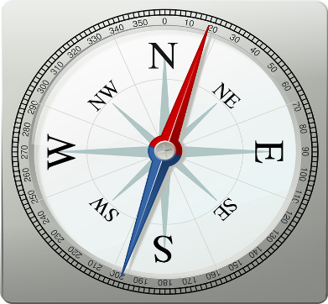
- south (n) \saʊθ\ : phía Nam
- north (n) \nɔːrθ\ : phía Bắc
- west (n) \west\ : phía Tây
- east (n) \iːst\ : phía Đông
- a village (n) \ˈvɪlɪdʒ\ : ngôi làng
- a town (n) \taʊn\ : thị trấn
- a city (n) \ˈsɪti\ : thành phố
- center (n) \ˈsen(t)ər\ : trung tâm

II/ Grammar – Structure: ( ghi vào tập)
- Present simple (review)
Where is …?
Is it …?
Ex: Where is Tom? – He is in a village.
Is it in the country? – Yes, it is.
III. Listen and choose True or False:
Hi, everyone. My name is Luca. I live in a small village on Burano Island. It’s in the north of Italy, about nine kilometers from Venice. You have to take a ferry to get here. It isn’t a big village, fewer than three thousand people live here. Burano is famous for its brightly painted houses. My house is bright yellow. A lot of tourists come here to take photos and buy souvenirs. Here we have warm summers and very cold winters. I love my village. It’s the best place in the world.
TRUE/FALSE
- Luca lives in a village on Burano Island. True/ False
- His hometown is in the south of Italy. True/ False
- It is a big village. True/ False
- There are many panited houses. True/ False

